SCROLL DOWN FOR ENGLISH

FFURFLEN GAIS

**Swyddog Cyfathrebu Digidol a Marchnata Dwyieithog**

I wneud cais am y rôl newydd a chyffrous hon, llenwch y ffurflen gais a ddarperir, a'i dychwelyd, ynghyd â'r **[Ffurflen Monitro Cydraddoldeb ac Amrywiaeth,](https://forms.gle/BjBBVTAKPhho42Pv5)** i Weinyddwr Ballet Cymru, Jenny Isaacs **[jennyisaacs@welshballet.co.uk](mailto:jennyisaacs@welshballet.co.uk)** .

**Y dyddiad cau ar gyfer derbyn ceisiadau yw hanner dydd, ddydd Llun 31 Mai 2021.**

Cysylltir â'r ymgeiswyr sydd ar y rhestr fer trwy neges e-bost, ac fe'u gwahoddir am gyfweliad **yn ystod yr wythnos sy'n dechrau ar 7 Mehefin 2021.** Cynhelir y cyfweliadau naill ai yn Ballet Cymru neu ar-lein dros Zoom.

Sicrhewch eich bod yn bodloni'r holl feini prawf hanfodol a restrir ym manyleb y person fel y nodir ym [Mhecyn y Swydd](https://welshballet.co.uk/yn-chwilio-am-rol-gyffrous-greadigol-yn-y-celfyddydau/).

**Hawl i Weithio yn y DU:** Bydd ymgeiswyr yn cael eu hystyried os gallant ddarparu tystiolaeth i gadarnhau eu cymhwysedd i weithio yn y DU.

**Deddf Diogelu Data 1998 a GDPR.** Mae Ballet Cymru yn gweithredu gweithdrefnau diogelu data a phreifatrwydd llym, ac mae'n rhaid i ni gael caniatâd cyn casglu unrhyw wybodaeth bersonol. Trwy lenwi'r ffurflen gais a darparu eich manylion mewn dogfennau eraill, rydych wedi derbyn ein cais i gael mynediad at y data. Ni fydd y manylion a ddarperir ar gyfer y ffurflen Cydraddoldeb ac Amrywiaeth yn cael eu defnyddio at ddibenion y broses gyf-weld; defnyddir y data a gesglir at ddibenion monitro ac adrodd yr elusen.

**COVID-19 a Phrotocolau Diogelwch**: trwy gydol y broses recriwtio a chyf-weld bydd Ballet Cymru yn ceisio darparu amgylchedd diogel, sy'n rhydd o COVID-19. Os bydd angen, gall Ballet Cymru ofyn am i'r ymgeiswyr sydd ar y rhestr fer gael eu profi am CV19 cyn dod i'r cyfweliadau yn swyddfeydd y Cwmni. Gellir cynnal cyfweliadau ar-lein trwy gytundeb gan bob parti.

| **MANYLION PERSONOL** | |
| --- | --- |
| Cyfenw |  |
| Enw(au) Cyntaf |  |
| Cyfeiriad e-bost: |  |
| Cyfeiriad Cartref yn cynnwys y Cod Post |  |
| Rhif ffôn Symudol |  |
| Rhif ffôn arall |  |

|  |  |
| --- | --- |
| CYMWYSTERAU A PHROFIAD | |
| Darparwch gopi o’ch CV sy’n cynnwys y manylion perthnasol | |
| **Enghreifftiau o'ch gwaith** | |
| Rhowch fanylion a/neu ddolenni i unrhyw gyfryngau y gallech fod wedi'u creu sy'n cyfleu eich gwaith, e.e. blogiau ar-lein, gwefan WordPress | |
| Dolenni i'r We | Manylion |
|  |  |
|  |  |
|  |  |
|  |  |

| Hygyrchedd a'r iaith Gymraeg |
| --- |
| Os oes gennych ofynion o ran mynediad neu os oes arnoch angen cymorth â'ch cais, cysylltwch â Jenny Isaacs yn Ballet Cymru **[jennyisaacs@welshballet.co.uk](mailto:jennyisaacs@welshballet.co.uk)** neu 01633 892927 ymlaen llaw. |
| Mae Ballet Cymru yn ymdrechu i fod yn sefydliad cynhwysol. Os cewch eich gwahodd i gyfweliad, byddwn yn anfon dogfen mynediad atoch fel y gallwn ddiwallu eich anghenion/dewisiadau orau o ran y cyfweliad. |

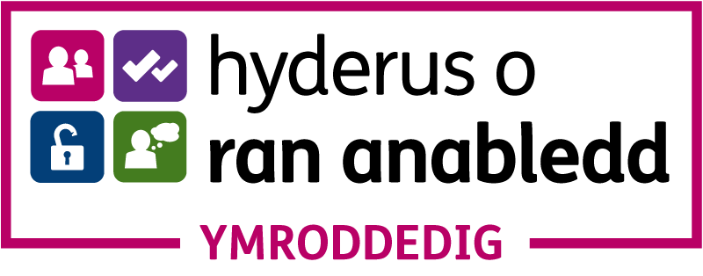

| DATGANIAD ATEGOL |
| --- |
| Dywedwch wrthym pam mai chi yw'r ymgeisydd delfrydol ar gyfer y rôl, sut yr ydych yn bodloni'r meini prawf a nodir ym manyleb y person, a nodwch unrhyw wybodaeth arall a fyddai'n cefnogi eich cais. Efallai y byddai'n ddefnyddiol strwythuro eich datganiad mewn penawdau yn unol â manyleb y person. Parhewch ar ddim mwy nag un dudalen ychwanegol os oes angen. |
|  |

|  |  |  |  |  |
| --- | --- | --- | --- | --- |
| GEIRDAON | | | | |
| Darparwch 2 x geirda gyda'ch cais. | | | | |
| **Canolwr 1** | | | | |
| Enw |  | | | |
| Teitl Swydd |  | | | |
| Cyfeiriad |  | | | |
| Ffôn |  | | | |
| Cyfeiriad e-bost: |  | | | |
| A allwn gysylltu â'r canolwr hwn cyn cynnig cyflogaeth? | | | | Gallwch  Na allwch |
| **Canolwr 2** | | | | |
| Enw |  | | | |
| Teitl Swydd |  | | | |
| Cyfeiriad |  | | | |
| Ffôn |  | | | |
| Cyfeiriad e-bost: |  | | | |
| A allwn gysylltu â'r canolwr hwn cyn cynnig cyflogaeth? | | | | Gallwch  Na allwch |
| MANYLION ERAILL | | | | |
| Ble y gwelsoch y swydd hon yn cael ei hysbysebu? E.e. Papur newydd, y cyfryngau cymdeithasol, gwefan, clywed rhywun yn sôn amdani | |  | | |
| A oes gennych hawl gyfreithiol i fyw a gweithio yn y DU? | | | Oes  Nac oes | |
| A yw hyn yn ddarostyngedig i gael trwydded waith? | | | Ydy  Nac ydy | |
| Bydd angen i chi ddarparu dull adnabod ffotograffig a phrawf o'r uchod os cynigir y swydd hon i chi. | | | | |
| A ydych erioed wedi eich cael yn euog o drosedd nad yw wedi'i disbyddu dan ddarpariaeth Deddf Adsefydlu Troseddwyr 1974? | | | Ydw  Nac ydw | |

|  |  |  |  |
| --- | --- | --- | --- |
| DATGANIAD | | | |
| Rwy'n datgan bod yr wybodaeth a roddir yn y cais hwn yn gyflawn ac yn gywir hyd eithaf fy ngwybodaeth. | | | |
| Llofnod |  | Dyddiad |  |
| ENW (PRINTIWCH) |  | | |

APPLICATION FORM

**Bilingual Marketing & Digital Communications Officer**

To apply for this brand new and exciting role, please complete and return the application form provided, along with the[**Equality and Diversity Monitoring Form**](https://forms.gle/BjBBVTAKPhho42Pv5)to Ballet Cymru’s Administrator, Jenny Isaacs [**jennyisaacs@welshballet.co.uk**](mailto:jennyisaacs@welshballet.co.uk)

**The deadline for receipt of applications is 12 noon on Monday 31 May 2021.**

Shortlisted applicants will be notified by email and invited for interview **during the week commencing 7 June 2021**. Interviews will be held either at Ballet Cymru or online via Zoom.

Please ensure that you meet all the essential criteria listed in the person specification as detailed in the [Job Pack](https://welshballet.co.uk/looking-for-an-exciting-creative-role-in-the-arts/).

**Right to Work in the UK:** Applicants will be considered if they can provide evidence to confirm their eligibility to work in the UK.

**Data Protection Act 1998 and GDPR.** Ballet Cymru operates strict data protection and privacy procedures and require consent before acquiring any personal information. In completing the application form and providing your details in other documents, you have accepted our request to access the data. Details provided for the Equality and Diversity form will not be used for the purposes of the interview process; data acquired will be used for the charity’s monitoring and reporting purposes.

**Covid-19 and Safety Protocols**: throughout the recruitment and interview process Ballet Cymru endeavour to provide a safe, Covid-free environment. If necessary, Ballet Cymru may request for shortlisted candidates to be tested for CV-19 prior to attending interviews at the Company’s offices. Interviews may take place online on agreement by all parties.

| PERSONAL DETAILS | |
| --- | --- |
| Surname |  |
| Forename/s |  |
| E-mail |  |
| Home Address & Postcode |  |
| Mobile |  |
| Other tel no. |  |

|  |  |
| --- | --- |
| QUALIFICATIONS & EXPERIENCE | |
| Please provide a copy of your CV with relevant details | |
| **Examples of your work** | |
| Please provide details and/or links to any media which you may have created which illustrate your work, eg online blogs, WordPress site | |
| Web link | Details |
|  |  |
|  |  |
|  |  |
|  |  |

| Accessibility & Welsh language |
| --- |
| If you have access requirements or need support in your application, please contact Jenny Isaacs at Ballet Cymru [jennyisaacs@welshballet.co.uk](mailto:jennyisaacs@welshballet.co.uk) or 01633 892927 in advance. |
| Ballet Cymru endeavour to be an inclusive organisation. If you are invited to interview, we will send you an access rider so we can best meet your interview needs/preferences. |



| SUPPORTING STATEMENT |
| --- |
| Please tell us why you are the ideal candidate for the role, how you meet the criteria stated in the person specification, and any further information that would support your application. It may be useful to structure your statement in headings according to the person specification. Continue on no more than 1 additional page if necessary. |
|  |

|  |  |  |  |  |
| --- | --- | --- | --- | --- |
| REFERENCES | | | | |
| Please provide 2 x references with your application. | | | | |
| **Referee 1** | | | | |
| Name |  | | | |
| Job Title |  | | | |
| Address |  | | | |
| Telephone |  | | | |
| E-mail |  | | | |
| Can we contact this referee prior to an offer of employment? | | | | Yes No |
| **Referee 2** | | | | |
| Name |  | | | |
| Job Title |  | | | |
| Address |  | | | |
| Telephone |  | | | |
| E-mail |  | | | |
| Can we contact this referee prior to an offer of employment? | | | | Yes No |
| OTHER DETAILS | | | | |
| Where did you see this post advertised? Eg Newspaper, social media, web site, word of mouth | |  | | |
| Do you have the legal right to live and work in the UK? | | | Yes  No | |
| Is this subject to having a work permit? | | | Yes  No | |
| You will need to produce photographic identification and proof of the above if you are offered this post. | | | | |
| Have you ever been convicted of a criminal offence which under the provision of the Rehabilitation of Offenders Act 1974 is not “spent”? | | | Yes  No | |

|  |  |  |  |
| --- | --- | --- | --- |
| DECLARATION | | | |
| I declare that the information given in this application is to the best of my knowledge complete and correct. | | | |
| Signature |  | Date |  |
| NAME (PLEASE PRINT) |  | | |

[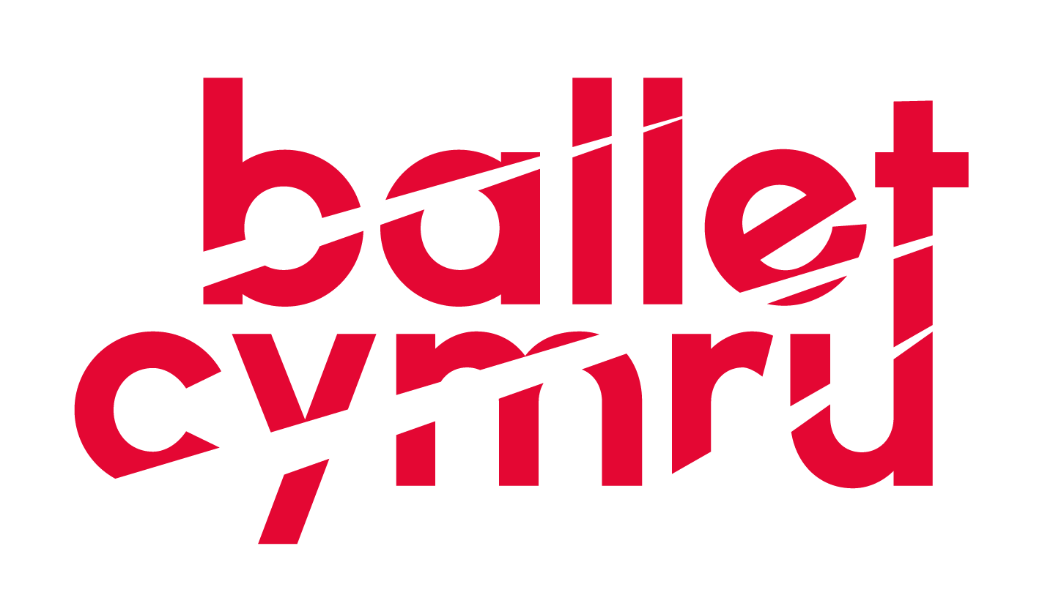](http://www.welshballet.co.uk)

|  |  |  |  |
| --- | --- | --- | --- |
| [http://cdn-images.mailchimp.com/icons/social-block-v2/color-facebook-48.png](https://www.facebook.com/balletcymru) | [http://cdn-images.mailchimp.com/icons/social-block-v2/color-twitter-48.png](https://twitter.com/balletcymru) | [ig-logo-email](https://www.instagram.com/balletcymru/) | [yt_icon_rgb](https://www.youtube.com/channel/UCusHNEiSVMvyNaYLIWtmWOg?view_as=public) |

Ffôn/ Tel: +44 (0)1633 892 927

|  |  |
| --- | --- |
| Ballet Cymru, Uned 1,  Stad Fasnachu'r Wern, Tŷ-du,  Casnewydd NP10 9FQ Cymru DU | Ballet Cymru, Unit 1  Wern Trading Estate, Rogerstone,  Newport NP10 9FQ Wales UK |
| Elusen Rhif 1000855 | Charity No. 1000855 |
| Cofrestredig yn Lloegr ac yng Nghymru fel  Gwent Ballet Theatre Cyf. 02535169 | Registered in England and Wales as  Gwent Ballet Theatre Ltd. 02535169 |

**Mae Ballet Cymru yn aelod o / Ballet Cymru is a member of**

One Dance UK, People Dancing, A&B Cymru/Arts & Business Cymru,

Celfyddydau Anabledd Cymru/Disability Arts Wales

Cynnal Cymru/Sustain Wales, GAVO.

**Mae Ballet Cymru yn cydnabod cefnogaeth gan /**

**Ballet Cymru is supported by**



Lottery_funding_strip_landscape_colour