February Half Term Inclusive
Online Dance Intensive

Break away from daily routine and join Ballet Cymru
for a burst of dancing fun in February half term.

16th – 18th February 2021
2.00pm-3.00pm
Interactive creative dance sessions via Zoom

Open to all ages and abilities
Suggested contribution £9

Join Ballet Cymru in this short burst of creative fun with dance activities that the whole family can join, putting a smile on everyone’s face and boosting your energy.

Sessions led by:
Access and Outreach Officer Louise Lloyd
& Company Dancer Joe Powell-Main

Ballet Cymru is an inclusive company and welcomes applications from dancers with disabilities and with any protected characteristics.

To apply please complete the application form and send to:
Louise Lloyd - louiselloyd@welshballet.co.uk
By Monday 15th February 2021.
Applications after this date may not be considered.

Please note that you may not receive an immediate response, but we will get back to you as soon as possible, thank you for your patience at this busy time.

supported by

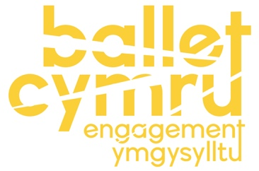
Please read the disclaimer below before completing and returning the consent form on the following page.

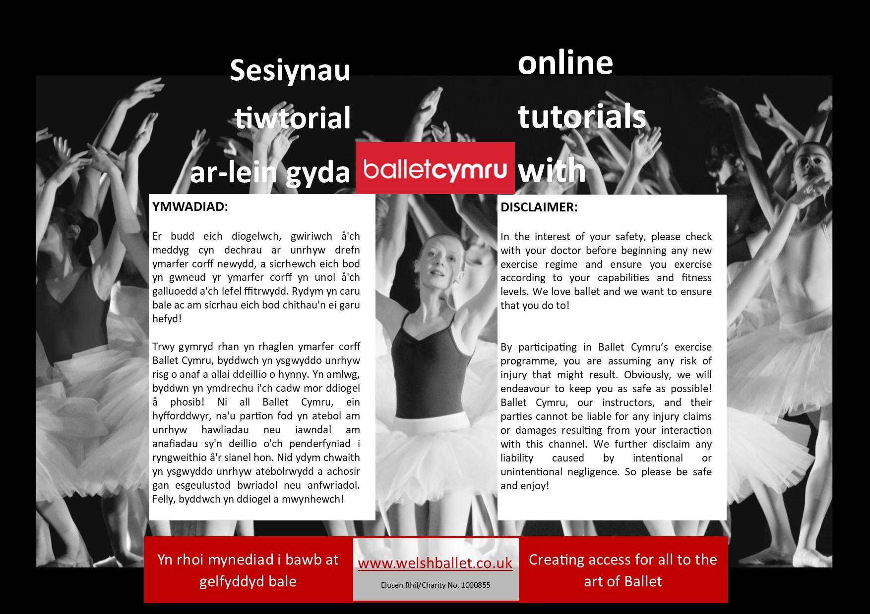

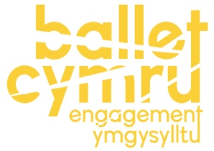
FEBRUARY HALF TERM
INCLUSIVE ONLINE DANCE INTENSIVE

APPLICATION FORM

Please complete and return to Ballet Cymru no later than Monday 15th February 2021.

Applicant Details
Full name:
Age: |  |  |  | Country of residence:
Postcode: |  |  |  | Email:
Name of parent/guardian (if under 18):
Please send your completed application form to Louise Lloyd: louiselloyd@welshballet.co.uk
How did you hear about this activity? E.g. social media, word of mouth |  |  | ………………………………………………………………

Please complete and return this application form to Ballet Cymru no later than

Monday 15th February 2021.

FREE BALLET CYMRU E-NEWSLETTER | LET’S BE FRIENDS!
Our e-newsletter is packed with the latest news and events, and it’s completely free! Sign up to our mailing list today by visiting www.welshballet.co.uk  By joining the mailing list, you consent to receive regular communications via email from Ballet Cymru and can unsubscribe at any time. Only your email address will be used for this purpose. | Support Ballet Cymru’s activities by joining our Friends Membership Scheme from just £15 per year*!  *Junior Membership is for 16 years and under, Adult and Joint Friends Memberships are also available. To apply for Friends Membership, please contact patriciavallis@welshballet.co.uk for more details, or ask one of the Ballet Cymru team.
BALLET CYMRU DATA PROTECTION & PRIVACY POLICY
We will never share your details with any third parties without your permission. Any personal data received will be held in compliance with Ballet Cymru’s Privacy & Data Protection Policy, current UK Data Protection laws and GDPR, with access restricted to authorised staff only. Data is retained only for the specific purposes which the individual has provided their details to be included or to participate in. Individuals have the right to request the deletion, rectification, objection or access to their personal data at any time. Data on individuals under 18 years old will not be obtained without requesting prior consent from the named parent/guardian confirmed on the application.
March 2020

Please complete and return this consent form to louiselloyd@welshballet.co.uk

Email address for course links:
Please confirm whether you have any additional needs, disabilities, or wish to inform us of any injuries or anything that may affect the way you participate in the activities provided:

Emergency Contact
Please provide details of someone other than the participant who would be best to contact, if necessary, regarding participation in the course.

Emergency contact name:
Emergency contact number:
Additional contact number (optional):

Media Consent
By participating in this course, you automatically provide consent for Ballet Cymru to take photographs and video footage and to use this, along with any photographs or video footage which you provide, to specifically promote and share Ballet Cymru’s education activities*.
*Photographs and videos may be used during the activities to publicise details of Ballet Cymru’s education programmes, and for reporting to funders and supporters of the charity. This may include the use of media on the Company’s official web site, social media pages and for sharing with other carefully selected media, e.g. local newspapers, but is not responsible for any third-party activity. You can withdraw your consent or request access to data provided at any time, in accordance with current UK regulations.

Please tick both boxes below to be admitted onto the course:
(if using Microsoft Word, you can tick the box by double clicking the box and selecting ‘ticked’)

I confirm that I have read Ballet Cymru’s disclaimer and wish to proceed with enrolling on the February Half Term Inclusive Online Dance Intensive.

I confirm that I understand that by participating in the February Half Term Inclusive Online Dance Intensive I am giving my consent for photographs and video footage of me to be used by Ballet Cymru to promote and share Ballet Cymru’s education activities.

Privacy Statement: All personal data provided above will only be used for the purposes of this specific activity only and will not be shared/disclosed at any time. Under current Data Protection and Privacy regulations data provided will be managed according to Ballet Cymru’s Data Protection Policy and you have the right to contact us to access, edit, delete any data provided at any time.

Signed  (parent/guardian if participant is under 18): |  | Date:

Please send the completed form to Louise Lloyd: louiselloyd@welshballet.co.uk

