Ballet Cymru

Amy Doughty

Assistant Artistic Director

10/22/2020

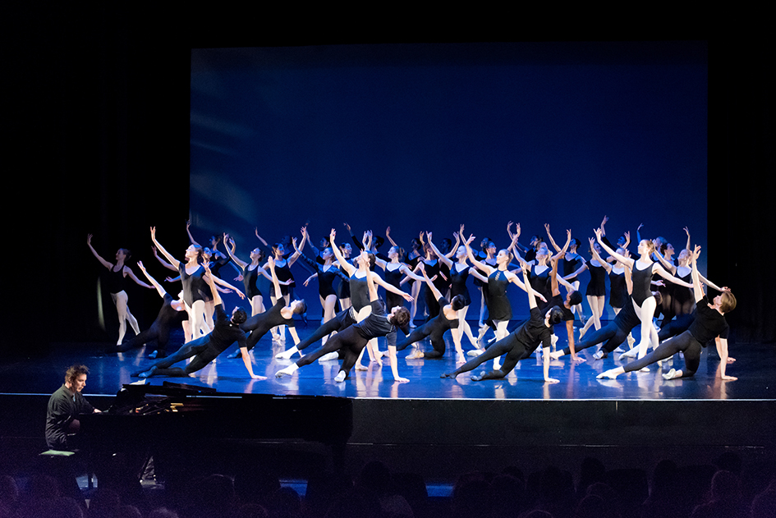

Ballet Cymru Associates Programme Officer

# **Ballet Cymru**

# **Associates Programme Officer**

Ballet Cymru’s **Associates Programme Officer** will help the company’s Award-Winning education team inspire and deliver Ballet Cymru’s established Associate Programme of work for young, dedicated and exceptional dancers.

The successful candidate will work closely with the Assistant Artistic Director for 9 months on a part-time basis from January 2021 to manage, organise and deliver pre-vocational ballet training. The Associates Programme Officer will also help Ballet Cymru seek out new ways to engage more diversity in the programme and new pathways for applicants. This role is both an administrative and dance delivery role.

This is a fantastic ‘Foot in the door’ opportunity to start working with an Arts Portfolio Wales company and to help develop this outstanding training programme and your role in it. Ballet Cymru welcomes **disabled, neuro-diverse, Black, Asian, and/or ethnically diverse applicants.**

|  |  |
| --- | --- |
| **Role:** | Associates Programme Officer |
| **Fee:** | £4,864 |
| **Hours:** | Based on 2 Sundays a Month sessions, Admin time, audition days, and a two-week intensive.  (Details on application) |
| **Dates:** | January – September 2021 (dates to be confirmed) |
| **Duration:** | Fixed term contract for 9 months (with potential for extension) |
| **Location:** | Based at Ballet Cymru’s studios in Newport (due to Covid-19 restrictions, some activities may be delivered online) |

TO APPLY: Please download the Job Application Pack from [**www.welshballet.co.uk**](http://www.welshballet.co.uk), or email [**jennyisaacs@welshballet.co.uk**](mailto:jennyisaacs@welshballet.co.uk) to request the pack. Please email your completed written application along with your CV and details of 2 referees **by 12pm on 20th November 2020**. Interviews will take place during the week of 30th November 2020 either at Ballet Cymru or via zoom.

APPLICATION PROCESS**:** Please apply in writing with a CV (detailing 2 referees), and a cover letter of no more than 2 pages, explaining why you are applying for the position and how you meet the requirements set out in the job description and person specification included this Application Pack.

We encourage applicants to also complete and return the[**Equality and Diversity Monitoring Form**](https://forms.gle/4W5UL24eUaxxshwe7)along with their application.

Shortlisted candidates will be contacted by phone or email. Interviews will take place during the week of the **30th November 2020** either at Ballet Cymru or online via Zoom.

**

# **Ballet Cymru**

# **Associates Programme Officer**

# **Job Description**

## MAIN DUTIES AND RESPONSIBILITES

The main responsibility of the Associates Programme Officer is to help manage and oversee the running of the Ballet Cymru Associate Programme. This includes a combination of on-site working (at Ballet Cymru for associate days, auditions and dance intensives) as well as administrative duties.

There is a requirement to teach a minimum 21 ballet classes (at intermediate/advanced level) and there is an expectation that the successful candidate will shadow some classes taught by the Assistant Artistic Director first to understand the way in which Ballet Cymru would like associate classes to be taught.

* **The Associates Programme Officer will also help identify and recruit additional guest teaching for associate days**

**to offer associates rounded dance training to enhance skills and knowledge.**

* **They will help care for the safety, health and well-being of Associates and will be a strong communicator with families.**
* **They will help manage associate applications and audition processes as well as the recruitment of associates onto the programme.**
* **They will oversee the summer intensives and help manage both mid and senior associate performances,**

**with the assistance of the Ballet Cymru team.**

* **They will be required to help with the monitoring, evaluating and reporting on the Associate programme.**
* **They will be excellent advocates of Ballet Cymru and the Associate Programme and whenever possible use social media to advertise and promote the programme.**
* **They will attend Ballet Cymru performances and company classes to meet dancers and staff and understand/embed the ethos of Ballet Cymru.**

## **Time requirements are:**

* **2 x Sundays (9am – 5.30pm) per month over 7 months on-site at Ballet Cymru**
* **Up to 3 Audition days (June/July 2021)**
* **2 x weeks/12 days associate summer school (25th July – 7th August) - this includes 2 performance days/eves**
* **Administrative duties (including general contact, registering audition applicants, managing auditions, month-to-month running of the programme, managing performances/intensives)**

Remote working is possible (if preferred) for the administrative aspect of the job which entails:

* **The month-to-month administrative running of the programme**
* **Scheduling and arranging guest teaching**
* **The process of applications and auditions**
* **Selection and recruitment of associates**
* **Dance Intensives and Performance preparations**
* **Associate database upkeep**

## **Additional duties:**

Additional duties may need to be undertaken from time to time and these can be discussed with the Artistic Directors of Ballet Cymru as and when they arise. Such duties may include:

* Opportunities to share the work of our associates through dance platforms
* Seeking funding streams
* Ways of developing the associate programme
* Undertake specific CPD training to enhance the skillset of the Associate Programme Officer including Equality Training, Mental Health First Aid Training, First Aid Training
* Representing Ballet Cymru at industry events

Additional responsibilities undertaken which fall outside of Associate Officer requirements will be financially compensated (with prior arrangement with Artistic Directors)

# PERSON SPECIFICATION

## **ESSENTIAL SKILLS/EXPERIENCE/QUALITIES:**

* Experience in ballet teaching and creative dance practices, ideally vocationally trained or equivalent
* Experience of working inclusively (or a passion to learn to do so) with people of all ages and abilities through dance
* An ability and genuine passion to help progress the talents and abilities of young people
* Excellent communication skills with the ability to draft/write letters, make/receive telephone calls, create and respond to e-mails etc.
* IT literate and confident in the use of PC based software such as Microsoft office etc.
* Well organised with a flexible and proactive approach to work and the ability to work to deadlines
* Willingness and ability to work both independently and as part of a team
* Enhanced DBS certification is essential for this role (to be applied for through Ballet Cymru)

## **DESIRABLE SKILLS/EXPERIENCE/QUALITIES:**

* Ability to speak Welsh/willingness to learn
* Licenced chaperone
* Experience in choreography
* Digital and social media skills
* Own transport may be beneficial for accessing Ballet Cymru out-of-hours and on weekend

# ABOUT BALLET CYMRU

## **OUR MISSION:**

BALLET CYMRU DELIVER OUTSTANDING PERFORMANCES

AND LIFE CHANGING ENGAGEMENT IN CREATIVE AND IMAGINATIVE WAYS.

WE ARE ADVOCATES FOR EXCELLENCE, SUSTAINABILITY AND INCLUSION IN BALLET

Ballet Cymru is an international touring ballet company for Wales, committed to inclusion and innovation in dance and classical ballet, and to the highest standard of collaboration. Its extensive Access and Outreach programme is committed to breaking down barriers to accessing the arts.

Artistic Director Darius James received his OBE in 2019 from Prince Charles for services to Ballet and Community Dance and directs the company alongside Assistant Artistic Director Amy Doughty who was a Paul Hamlyn Foundation JADE Fellow and leads the company’s ground-breaking inclusive education work.

Patrons of the company include Cerys Matthews MBE and ex-Royal Harpist Catrin Finch, who also collaborate on work.

The company’s major stakeholders are The Arts Council of Wales, The Paul Hamlyn Foundation and The Garfield Weston Foundation.

Ballet Cymru became a Revenue client of The Arts Council of Wales in 2011 and is one of only two Arts Portfolio Wales Dance companies in Wales.

Ballet Cymru has won several major dance awards: Winners of the Best Dance Production at the Wales Theatre Awards in 2014, 2017 and 2018. UK Critics’ Circle National Dance Award Winners in 2006. Nominations for UK National Dance Award as Best Independent Company in 2013, 2016, 2017 and 2018.

Manylion Cyswllt

/Contact Details

**Cyfarwyddwr Artistig / Artistic Director**

Darius James OBE [dariusjames@welshballet.co.uk](mailto:dariusjames@welshballet.co.uk)

**Cyfarwyddwr Artistig Cynorthwyol / Assistant Artistic Director**

Amy Doughty  [amydoughty@welshballet.co.uk](mailto:amydoughty@welshballet.co.uk)

**Gweinyddwr / Administrator**

Jenny Isaacs  [jennyisaacs@welshballet.co.uk](mailto:jennyisaacs@welshballet.co.uk)

**Swyddog Cyfathrebu / Communications Officer**

Patricia Vallis  [patriciavallis@welshballet.co.uk](mailto:patriciavallis@welshballet.co.uk)

**Swyddog Mynediad ac Allgymorth / Access & Outreach Officer**

Louise Lloyd  [louiselloyd@welshballet.co.uk](mailto:louiselloyd@welshballet.co.uk)

**Duets Rheolwr Prosiect / Project Manager**

Louise Prosser [louiseprosser@welshballet.co.uk](mailto:louiseprosser@welshballet.co.uk)

**Cyfarwyddwyr / Directors**

Cadeirydd/Chair: Jên Angharad

Is-gaderiydd/Vice Chair: Fiona Creedon

Sarah Cash, Susanne Bradley, Gareth Rees,

Catherine Batt, Jeffrey Greenidge

**Noddwyr / Patrons**

Richard Glasstone MBE, Cerys Matthews MBE,

Gwyn Vaughan Jones, Catrin Finch

**Syflaenydd / Founder**

Yvonne Greenleaf

**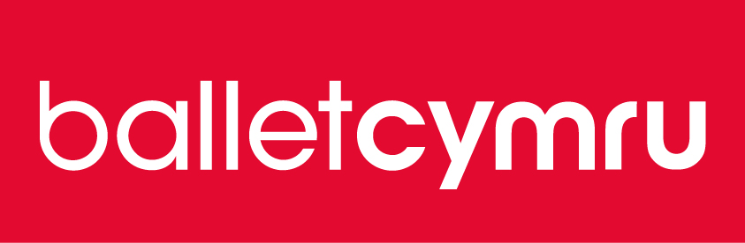**

[**www.welshballet.co.uk**](http://www.welshballet.co.uk)

Ffôn/ Tel: +44 (0)1633 892 927

|  |  |
| --- | --- |
| Ballet Cymru, Uned 1, Stad Fasnachu'r Wern, Tŷ-du, Casnewydd NP10 9FQ Cymru DU | Ballet Cymru, Unit 1 Wern Trading Estate, Rogerstone, Newport NP10 9FQ Wales UK |
| Elusen rhif 1000855 | Charity No. 1000855 |
| Cofrestredig yn Lloegr ac yng Nghymru fel  Gwent Ballet Theatre Cyf. 02535169 | Registered in England and Wales as  Gwent Ballet Theatre Ltd. 02535169 |

**Mae Ballet Cymru yn aelod o / Ballet Cymru is a member of**

One Dance UK, People Dancing, A&B Cymru/Arts & Business Cymru,

Celfyddydau Anabledd Cymru/Disability Arts Wales

Cynnal Cymru/Sustain Wales, GAVO

**Mae Ballet Cymru yn cydnabod cefnogaeth gan /**

**Ballet Cymru is supported by**

Lottery_funding_strip_landscape_colour