APPLICATION PACK
FOR THE ROLE OF

CHAIR OF THE BOARD OF TRUSTEES

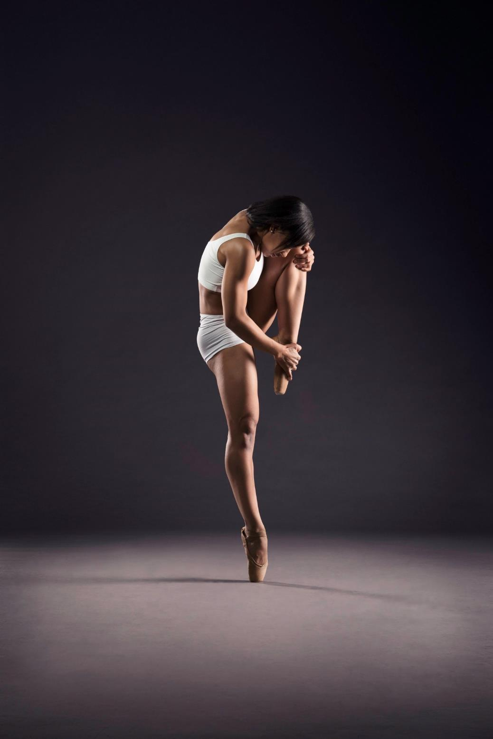
© Si$â$n Trenberth Photography
BALLET CYMRU is an award-winning professional ballet company, producing original professional dance performances which tour nationally throughout Wales and the UK, with exciting plans to develop both UK and international touring activity in the next few years.
The Company is committed to inclusion and innovation in dance and classical ballet, seeking original and imaginative ways to engage with all ages and abilities both locally in its hometown of Newport and nationwide.
Alongside its touring activity, Ballet Cymru offers a range of accessible outreach programmes for young people and diverse communities to engage in dance up to professional level. The organisation is renowned in the sector for ground-breaking work in inclusive practice.
Ballet Cymru is committed to the highest standards in dance and classical ballet. The Company regularly collaborates with, choreographers, designers, composers and musicians, including harpist & composer Catrin Finch, BBC National Orchestra of Wales, singer Cerys Matthews MBE, and international guest artists.
- Winners of the Best Dance Production at the Wales Theatre Awards 2014, 2017, 2018.
- Winners of the UK Critics’ Circle National Dance Audience Award 2006.
- Nominations for Best Independent Company UK Critics’ Circle National Dance Awards 2013, 2016, 2017 & 2018.
- Artistic Director Darius James was awarded an Order of the British Empire (OBE) by HRH Prince Charles at the New Year’ Honours ceremony in January 2019.
Ballet Cymru currently have five full-time staff - Artistic Director, Assistant Artistic Director, Duets Manager, Access and Outreach Officer and Administrator. The company is led by the Artistic Director and Co-founder Darius James OBE. There are currently two part-time/freelance roles; Communications Officer and Premises Manager.

BOARD OF TRUSTEES
Our Board of Trustees ensure the charity operates in the best interests of the public and complies with and reports to regulatory bodies, including The Charity Commission. Each Trustee contributes his/her professional expertise and experience to support the company’s commitment to achieve best practice throughout the organisation and advocating its work.
Ballet Cymru is registered in England and Wales as Gwent Ballet Theatre Ltd., No. 02535169
Registered Charity No. 1000855
Further details of Ballet Cymru’s team and current board members can be found on our web site www.welshballet.co.uk

THE ROLE
The Chair of the Board will work in partnership with the Artistic Directors and Board to support the vision of the Company, to enhance its reputation for artistic excellence and innovation, to reach an increasingly diverse audience and to ensure its financial resilience.
The specific responsibilities of the Chair are to work with the Artistic Directors and Board to:
- Develop and deliver the artistic vision for the Company.
- Develop and deliver a programme of engagement and participation that is integral to the artistic vision and programming.
- Oversee the long-term financial planning for realising the vision of the Company.
- Nurture and support the growth, wellbeing and development of the Company
- Act as an ambassador, advocate and spokesperson for the Company in Wales, the UK and internationally.
- Help to grow the support of individual donors, corporate sponsors, trusts and foundations.
- Ensuring that equality, diversity and inclusion are at the heart of how the Company operates, builds its programmes and partnerships and connects with its audiences.
The role is voluntary, and previous board or Trustee experience is preferred? Trustees are expected to attend regular board meetings (either in person or online), as well as fundraising events and other activities, which are usually held at the charity’s premises located in Newport, or online.

THE PERSON SPECIFICATION
The successful candidate will ideally have, and be able to demonstrate, exceptional communication and representational skills – with the ability to inspire and enthuse others, both within the Company and outside.
They must demonstrate the appreciation, understanding and preferably the experience of:
- Dance and/or ballet.
- How an arts organisation operates.
- The infrastructure of the arts in Wales
- The financial and commercial constraints on a small-scale touring company and the ability to oversee budgets and accounts.
- Current UK regulations for charity governance and accountability
- Working with diverse community groups or those in disadvantaged communities
- Experience or knowledge of best practice in equality, diversity and inclusion
- The Welsh Language
Overall, the successful candidate will have personal qualities of energy, enthusiasm, openness, tolerance and fairness; and an intolerance of bullying and discrimination.
Ballet Cymru is actively seeking to challenge discrimination and promote equality and diversity in the arts. We therefore welcome applications from all sections of our community, including disabled (differently abled), neuro-diverse, Black, Asian, or ethnically diverse.

Reporting To: The Board of Trustees
Term of Office: 2 terms of three years, subject to majority vote by the Board each term
PROPOSED AD COPY

CHAIR
Ballet Cymru is looking for its next Chair to work in partnership with the Artistic Directors and Board to support the vision of the Company, to enhance its reputation for artistic excellence and innovation, to reach an increasingly diverse audience and to ensure its financial resilience.
Candidates will need to demonstrate, exceptional communication and representational skills – with the ability to inspire and enthuse others, both within the Company and outside.
Overall, you will need to have personal qualities of energy, enthusiasm, openness, tolerance and fairness; and an intolerance of bullying and discrimination.
Ballet Cymru is actively seeking to challenge discrimination and promote equality and diversity in the arts. We therefore welcome applications from all sections of our community, including disabled (differently abled), neuro-diverse, Black, Asian, or ethnically diverse.
The role is voluntary, and previous board or Trustee experience is preferred.
Ballet Cymru is registered in England and Wales as Gwent Ballet Theatre Ltd.
No. 02535169
Registered Charity No. 1000855

TO APPLY
Please complete the application form available to download from our web site www.welshballet.co.uk and submit, along with your CV and/or Personal Statement and the Equality and Diversity Monitoring Form to jennyisaacs@welshballet.co.uk
DEADLINE: LATEST 12 NOON MONDAY 14th SEPTEMBER 2020.
Please contact us if you have any special requirements or access needs.

Name

Home Address |  |  |  |  | Postcode
Telephone | Home/Work |  |  | Mobile
Email
Occupation

Qualifications
Which of the following skills or experience could you bring to the Board? | Please indicate against each relevant area your skills and their levels, with 1 being the highest and 5 the lowest level;
 | Equal Opportunities |  |  | Education & Training
 | Human Resources |  |  | Business Management
 | Financial / Accounting |  |  | Marketing and Publicity.
 | Fund Raising /Business Development |  |  | Communications and PR
 | Legal |  |  | Creative (please state sector/specialism)
 | Welsh Language Proficiency |  |  | Voluntary/Third Sector work
 | Other (please state)

The Person Specification outlines some of the key skills we seek in a potential Trustee. Please indicate against each of the following how you think your own skills and experience would enable you to fulfill the role of a Trustee as described in the Role Description. You may also want to enclose a CV with this application.
Key skills | Narrative
- Commitment to Ballet Cymru’s aims and visions
- Interpersonal

- Teamwork

- Communication
- Drive and determination
- Strategic perspective
- Intellectual and technical ability
- Leadership
- Experience and understanding of the Welsh arts/ creative/dance sector
- Experience and understanding of accessibility and inclusive practice
- Current Circumstances
- Equal Opportunities & diversity
- Business management

Why do you wish to become a trustee of Gwent Ballet Theatre Limited?

Are you currently, or have you in the past been on the Board of any other organisation? If so please give details;

Please confirm if you, or if you have ever been in connection with any other business that has been:
- Convicted of or charged (but not yet tried) with any criminal offence other than Motoring offences or spent convictions under the Rehabilitation of Offenders Act 1974 – YES/NO
- declared bankrupt or insolvent YES/NO
- A trustee or director or partner of a charity or company that went into liquidation or receivership -YES/NO
- The subject of a recovery action by Customs and Excise or the Inland Revenue - YES/NO
- The subject of a County Court Judgement - YES/NO
Please provide a brief explanation if you have answered yes to any of the above.

Please give details of two people who would be willing to provide a reference
Name | Name
Address  Postcode | Address  Postcode
Tel. | Tel.

_________________________________ ______________________
Name (please print Date

Please email the completed application, along with a copy of your CV and the EQUALITY AND DIVERSITY MONITORING FORM to:
Jenny Isaacs, Administrator at Ballet Cymru
jennyisaacs@welshballet.co.uk

How did you hear about this opportunity?
Ballet Cymru Website
Other Web Site Please specify …………………………………………………….
Social Media Please specify …………………………………………………….
Word of mouth
Other Please specify …………………………………………………….

Equality and Diversity Monitoring Form
Ballet Cymru is actively seeking to challenge discrimination and promote equality and diversity in the arts. We therefore welcome applications from all sections of our community, including disabled (differently abled), neuro-diverse, Black, Asian, or ethnically diverse.
We encourage applicants to also complete and return the Equality and Diversity Monitoring Form along with the application. This form will not be used during the short-listing process but will be used solely for the purpose of recruitment monitoring and provision of statistical data to our funders.
All information supplied will be treated in the strictest confidence and in accordance with the Company’s Equality & Diversity Policy and Privacy and Data Protection Policy, and in line with GDPR.
The form can be completed online via this link: Equality and Diversity Monitoring Form
Cyfarwyddwr Artistig / Artistic Director
Darius James OBE dariusjames@welshballet.co.uk

Cyfarwyddwr Artistig Cynorthwyol / Assistant Artistic Director
Amy Doughty amydoughty@welshballet.co.uk

Gweinyddwr / Administrator
Jenny Isaacs jennyisaacs@welshballet.co.uk

Swyddog Swyddog Cyfathrebu / Communications Officer
Patricia Vallis patriciavallis@welshballet.co.uk

Swyddog Mynediad ac Allgymorth / Access and Outreach Officer
Louise Lloyd louiselloyd@welshballet.co.uk

Rheolwr Prosiect DUETS / DUETS Projects Manager
Louise Prosser louiseprosser@welshballet.co.uk

Hyrwyddwr Amrywiaeth / Diversity Champion
Krystal Lowe

Bwrdd y Cyfarwyddwyr / Board of Directors
Cadeirydd/Chair: Ruth Till MBE
Is-gaderiydd/Vice Chair: Fiona Creedon
Cyfarwyddwyr / Directors: Sarah Cash, Susanne Bradley, Gareth Rees,
Catherine Batt, Jeffrey Greenidge

Noddwyr / Patrons
Richard Glasstone MBE, Cerys Matthews MBE,
Gwyn Vaughan Jones, Catrin Finch

Syflaenydd / Founder
Yvonne Greenleaf

welshballet.co.uk
Ffôn / Tel: (+44) 01633 892927

Mae Ballet Cymru yn aelod o / Ballet Cymru is a member of
One Dance UK, People Dancing, Arts & Business Cymru,
Cynnal Cymru/Sustain Wales, South Wales Chamber of Commerce, Disability Arts Wales
Mae Ballet Cymru yn cydnabod cefnogaeth gan / Ballet Cymru is supported by

