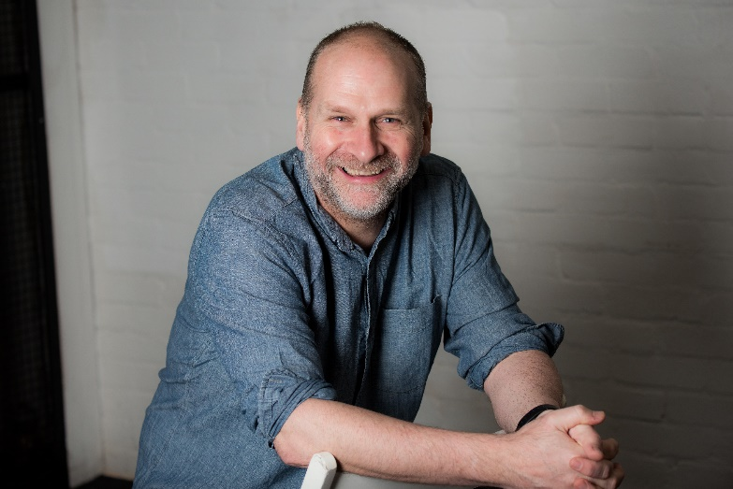

BIOGRAPHY
Darius James Williams
Artistic Director
BALLET CYMRU

Darius is from Newport in South Wales and trained at The Royal Ballet School, Lower and Upper Schools. As a dancer he worked with Northern Ballet Theatre and Alexander Roy London Ballet Theatre where he toured throughout the world, including the USA and Europe. Darius also guested as a dancer with companies internationally. As a teacher he lectured at Pontypool College (GCSE Dance) and at Swansea College (Ballet ‘A’ Level) and has been a guest teacher and adjudicator for the Cecchetti Society and BBC Young Dancer of the Year.

Darius founded Ballet Cymru in Newport in 1986 and is still Artistic Director, guiding the company to attain Arts Portfolio Wales Status in 2011. He is passionate about making ballet inclusive and accessible for all and constantly strives to create balletic work which is relevant, exciting and innovative. He has choreographed many one-act and full-length productions for the company including two Award Winning productions Romeo a Juliet and Roald Dahl’s Little Red Riding Hood. In 2008 Darius received a Creative Wales Major Award from the Arts Council of Wales, presented to him by Rhodri Glyn Thomas AM, Minister for Heritage. Darius has featured in Who’s Who since 2012 and was made an Honorary Vice President of The London Ballet Circle in 2013.

Quote

“I am excited and hugely honoured to be recognized for the work we are doing in Wales with Ballet Cymru. Over the past 32 years I have directed the company through good and tough times, including 13 years without any funding at all, but it has been a passion and a delight.

To have started the company in 1986 with £1000 from The Enterprise Allowance Scheme to the present day as an Arts Portfolio Wales client of The Arts Council of Wales has been a rollercoaster ride but I look forward to the future with excitement.

I am hugely indebted to my wife Amy and my two children, Cai (2) and Issy (5), and to The Arts Council of Wales and Welsh Government for believing in me, supporting the Arts in the City of Newport and helping me to challenge people’s perceptions of ballet.”

About Ballet Cymru
Ballet Cymru is an international touring ballet company
that is distinctively Welsh.

Ballet Cymru is committed to the highest standards in dance and classical ballet. The Company regularly collaborates with choreographers, designers, composers, musicians and many other international artists, including harpist and composer Catrin Finch, BBC National Orchestra of Wales, and Welsh icon Cerys Matthews MBE.

Ballet Cymru produce original professional dance performances based in the ballet technique which tour nationally throughout the UK including most major venues in Wales. The company is at the forefront of inclusive ballet training and produces extensive outreach and education work both in its home city of Newport and throughout Wales.

Ballet Cymru is an Arts Portfolio Wales client of The Arts Council of Wales and is supported by The Welsh Government.

Winners
Winners of Best Dance Production at the Wales Theatre Awards 2018, 2017 & 2014.
Critics’ Circle National Dance Award 2006.

Nominations
Critics’ Circle National Dance Award for Best Independent Company 2018, 2017 & 2014.
Best Dance Production at the Wales Theatre Awards 2018, 2015 & 2013.

Contact
dariusjames@welshballet.co.uk

Ballet Cymru
Unit 1, Wern Trading Estate
Rogerstone, Newport NP10 9FQ
Tel: +44 (0)1633 892927
www.welshballet.co.uk

Charity No. 1000855
Registered In England and Wales as Gwent Ballet Theatre Ltd.
No. 02535169

