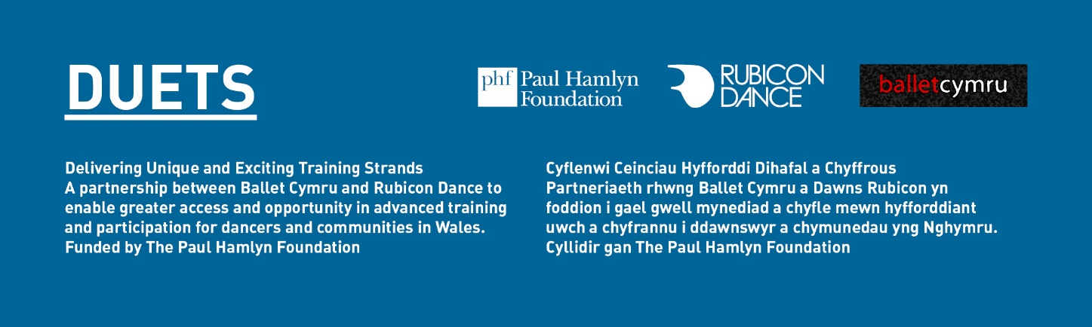Recruitment Pack
&
Application Form

Job Application:
DUETS External Evaluator Consultant

Job Application: DUETS External Evaluator Consultant
Thank you for your interest in this vacancy. Please find enclosed the following;
- Information about DUETS and the project partners, Ballet Cymru and Rubicon Dance
- Job Description
- Person Specification
- Application Form
- Equal Opportunities Monitoring Form
If you wish to apply for the post, please complete the relevant forms electronically, and send to;
jennyisaacs@welshballet.co.uk
If you wish to return them by post, please write clearly in black ink, and return to;
DUETS, Ballet Cymru, 1 Wern Industrial Estate, Rogerstone, Newport NP10 9FQ

Deadlines and Dates
Closing date for applications: 12 noon Monday 16 October 2017
Start date: ASAP
We regret that applications received after the closing date/time cannot be considered.
Good luck with you application!
Ballet Cymru is an Equal Opportunities Employer
DUETS is funded by
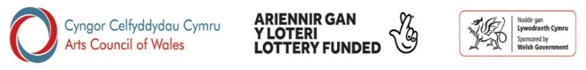

www.welshballet.co.uk

About DUETS
What is DUETS?

DUETS was a 3-strand programme of work devised and delivered by professional ballet company, Ballet Cymru, and community dance organisation, Rubicon Dance. The DUETS pilot programme ran for three years from September 2012 to July 2015 and was designed to give access to tailored dance training and participation opportunities for dancers and communities in Wales.

DUETS encompassed 3 strands of activity;

Strand 1: Workshops
The aim of Strand 1 was to nurture the talent of children and young people from challenged backgrounds, and to broaden skills and knowledge through new life experiences surrounding dance and the arts. Working with over 1,000 children each year from in Years 3, 4 & 5 in local Primary Schools, each school received workshops in both street and ballet. Over the 3-year life Span of DUETS, Ballet Cymru and Rubicon Dance delivered 180 workshops each in 10 schools in Newport and Cardiff. These schools were identified in Year One and, building on these relationships with the schools, were revisited in Years Two and Three.

From these 10 schools, 30 children were selected annually to embark on a 2-year dance-training Scholarship programme, delivered weekly by Ballet Cymru and Rubicon Dance. Graduate Scholars have been assigned to flagship dance groups, and are accessing ballet classes, contemporary and street classes and youth dance groups throughout South Wales.

Strand 2: Residencies
DUETS Strand 2 aims have been to broaden participation and awareness of dance throughout communities in Wales through a series of bespoke and diverse residencies. These residencies, tailored to suit the needs of each group involved, are designed to encourage access, participation, understanding, observation and enjoyment of dance.

Strand 3: Professional Placements
DUETS also provided practical teacher training for professional dancers/artists. By creating a series of intensive work placements that are flexible and tailored to specific and individual needs, these professional placements help to expand career development for professional dancers in Wales.

The 3 strands have worked both independently in their own right but also linked with each other to create a rounded and consistent programme of dance training. DUETS aim was to fill an identified void in areas of dance provision in Wales, particularly targeting people living in areas of poverty and those who have had minimal opportunity to experience dance and the arts.

Programme Objectives
To develop and implementation of an education strategy that:
  - Promotes the idea that participation in the arts is an integral and essential part of everyday life

  - Supports those methods of dance practice that build a bridge of understanding between all cultural and social groupings throughout Wales

  - Promotes dance as an outlet of physical, creative and intellectual energy for young and old, able and differently-able bodies, beginner to professional practitioner

An evaluation of the 3 year pilot programme demonstrated its success in helping many young people find a new path in life.

DUETS Explore & Test Phase

In 2017 funding was awarded from the Paul Hamlyn Foundation and the Arts Council of Wales to further develop the DUETS pilot project in an Explore & Test stage. This will be an exciting 1-year phase of the DUETS programme, developing existing practice to create a sustainable framework, with possible subsequent roll-out to a Wales-wide longer-term programme.

DUETS is funded by;

About the Partner Organisations
Ballet Cymru and Rubicon Dance have come together to forge a unique partnership between a professional ballet company and a participatory dance organisation in the Welsh Dance Sector to offer scholarships for training to talented young dancers, provide an advanced training provision for professional dancers and widen awareness about dance throughout Wales through a series of bespoke residencies.

Ballet Cymru
Ballet Cymru is the only professional ballet company in Wales, producing original professional dance performances based in the ballet technique which tour nationally throughout the UK including most major venues in Wales. It also produces education work both in its home city of Newport and in the towns and cities it visits on its touring programme.
www.welshballet.co.uk

Gwent Ballet Theatre Ltd Registered Charity no. 1000855

Rubicon Dance
Rubicon is the community dance development organisation for Cardiff and Newport and was one of the first of its kind in the UK. For over 40 years Rubicon has provided dance for people of all ages and abilities in a variety of community settings and whose aim is to provide consistent access to high quality dance activities within a policy of equal opportunity and open access.
www.rubicondance.co.uk
Welsh Dance Theatre Trust Ltd Registered Charity No 269068
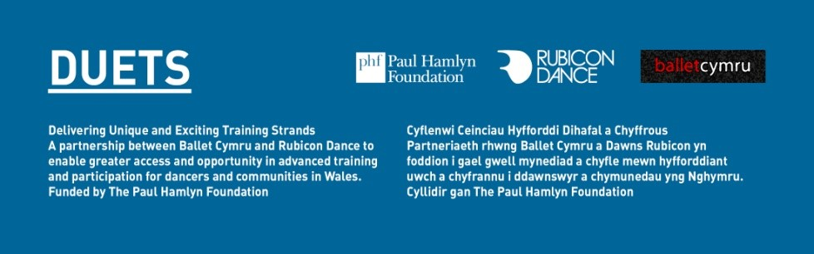
DUETS External Evaluator Consultant
Ballet Cymru wishes to appoint an External Evaluation Consultant to support the D.U.E.T.S programme partners, Ballet Cymru and Rubicon Dance, to assess, evaluate and learn from activities undertaken as part of the DUETS year-long Explore and Test phase 2017-18.
Background
DUETS (Developing Unique & Exciting Training Strands) is an exciting project funded by Paul Hamlyn Foundation and the Arts Council of Wales. The pilot DUETS project ran for 3 years from 2012-2015 and aimed to address inequalities in access to ballet for children and young people in Newport and Cardiff. The evaluation of the pilot demonstrated its success in helping many young people find a new path in life. However, to fully understand and exploit a potentially bigger and national DUETS programme, we need to dig deeper into evidence and evaluation through a second stage pilot to ensure we are capturing everything we know to sustain a larger DUETS programme.
The work will enable us to re-look at how we are addressing inequalities of opportunities to access and participate in the arts, to understand how we could do this better, and to implement new methods in developing a framework which may help achieve the programme’s goals more successfully in the future.
DUETS activity will be delivered over 3 strands:
(1) Schools & Scholarships
(2) Diverse residencies
(3) Professional Placement

Strand 1 will involve a primary school in Cardiff in an area of high deprivation. It will involve workshops and talent identification and recruitment for a weekly dance scholarship programme. Working closely with the school in this way will test its effectiveness for reaching those deemed ‘hardest-to-reach’ and those living in isolated populations, helping to underpin a potential national programme. Strand 1 will rely on strong partner recruitment/training and will closely link to the new changes in the national curriculum affecting Wales from 2018.

Strand 2 involves two diverse and inclusive dance residencies, encouraging prolonged dance engagement with outcomes appropriate for, and identified by, each group involved.

Strand 3 involves 2 x 6 month Professional Placements which will align with CCSkills National Occupational Standards for dance leadership.
Vitally, alongside this activity and using evidence from the DUETS pilot we will develop and implement a learning and evaluation framework, aided by an External Evaluation Consultant.

The Role
The role of the External Evaluation Consultant for the DUETS programme is to:
- Advise on methodology for recording evidence of impact and learning against the evaluation framework
- Assist in the analysis and formatting of reporting
- Identify key success factors and challenges;
- Act as a ‘critical friend’ to the project checking and challenging progress and facilitating review days, round table meetings and reflection sessions;
- Build our capacity in relation to evaluation and learning;
- Explore potential partnerships that might enhance the research base of the programme;
- Contribute to final report/publication
- Build on the existing evaluation framework to explore the potential of a longer-term project to be rolled out across Wales;
- Work closely with us to maximize the learning accrued throughout this pilot project and subsequently share it with the wider sector through our dissemination plan.

Person Specification
Essential
- Monitoring and evaluation skills
- Relevant evaluation experience and evidence of successful outcomes
- Excellent communication skills (both written and verbal) and excellent interpersonal skills
- Knowledge of the arts in Wales and familiarity with the Welsh Government aims and objectives for children and young people
- Knowledge of community dance and inclusivity, equality and diversity issues
- Awareness of current arts practice across Wales and the UK.
- An understanding of the needs of all participants, partner organisations and sections of the community, promoting equality and diversity
- Knowledge of not for profit organisations

Desirable
- Ability to communicate in Welsh
- Clean, full drivers licence
- Enhanced DBS

General
- To be a strong advocate for DUETS and promote the Programme’s brand and identity.

Length of contract: 8-10 days over 12 months of the programme
Fee: £8K (including project related travel and accommodation expenses)
Location Home-based, but able to attend key meetings/events in Wales
Deadline for applicants: 12 noon Monday 16 October 2017
Start date: ASAP

Please complete the application form and Equal Opportunities Form enclosed, and return with any relevant information/CV to;

Email jennyisaacs@welshballet.co.uk
Post: DUETS, Ballet Cymru, 1 Wern Trading Estate, Rogerstone, Newport NP10 9FQ
Please note unfortunately we are only able to respond to applicants who are selected for interview.

Ballet Cymru is an equal opportunities employer
This notice is also provided in Welsh
Alternative accessible formats are available on request.

DUETS is funded by;

www.welshballet.co.uk
Charity No.|Elusen Rhif. 1000855
Registered in England and Wales as Gwent Ballet Theatre Ltd. 02535169
|Cofrestredig yn Lloegr ac yng Nghymru Gwent Ballet Theatre Cyf.. 02535169

APPLICATION FORM

All sections, including the attached equal opportunities monitoring form, must be completed by applicants electronically or written clearly in black ink, and returned by the deadline. Please ensure that you meet all of the essential criteria listed in the person specification.

If you have any access needs or if there are any ‘reasonable adjustments’ we can make to assist you in your application, please contact Jenny Isaacs at Ballet Cymru jennyisaacs@welshballet.co.uk or 01633 892927 in advance.

PERSONAL DETAILS
Title
Surname
Forename/s
Address
 |  |  | Postcode:
Home tel. |  | Work tel.
Mobile |  | E-mail

REFERENCES
Referee 1
Name |  |  |  | Job Title
Address
 |  |  |  |  |  | Postcode:
Telephone |  |  |  | E-mail
Are we able to contact this referee prior to an offer of employment? |  |  |  |  |  | Yes No
Referee 2
Name |  |  |  | Job Title
Address
 |  |  |  |  | Postcode:
Telephone |  |  | E-mail
Are we able to contact this referee prior to an offer of employment? |  |  |  |  |  | Yes No

EMPLOYMENT HISTORY
Present or most recent employment
Starting with your most recent job, please give a summary of all employment, including any relevant unpaid work. Please explain any breaks in employment dates. If part-time, please state number of hours per week worked.
Role

Employer
Address
 |  |  |  |  |  |  | Postcode:
Dates of employment |  |  |  | From |  |  | To
Salary/Rates of pay
Reason for leaving / wishing to leave
Period of notice required
Give a brief outline of your responsibilities and duties
Previous Employment
Dates |  |  | Employer |  | Post title / Main duties |  |  |  | Reason for leaving
From | To

QUALIFICATIONS
Educational qualifications
Please give details of your education and qualifications (most recent first)
Dates |  | School, College, University etc | Subject (s) Studies |  | Qualifications/ Certificate / Grades
From | To
Work related accredited training and/or professional qualifications
Dates |  | Details – Name of association / qualifications etc |  | Level / Grade
From | To
Relevant Training
Dates |  | Title of Course |  | Details
From | To

SUPPORTING STATEMENT
Please tell us why you are the ideal candidate for the role, how you meet the criteria stated in the person specification, and any further information that would support your application. It may be useful to structure your statement in headings according to the person specification. Continue on no more than 1 additional page if necessary.

OTHER DETAILS
Where did you see this post advertised?
Do you have the legal right to live and work in the UK? |  | Yes No
Is this subject to having a work permit? |  | Yes No
You will need to produce photographic identification and proof of the above if you are offered this post.
Have you ever been convicted of a criminal offence which under the provision of the Rehabilitation of Offenders Act 1974 is not “spent”? |  | Yes No
In the event of a successful application a DBS certificate may be requested from the candidate as a condition of appointment. A criminal record will not necessarily be a bar to obtaining a position.
Are there any dates when you will be unavailable for interview? |  | Yes No
If yes please provide dates:

DECLARATION
I declare that the information given in this application is to the best of my knowledge complete and correct.
Signature |  | Date

Please return your completed application form along with the equal opportunities monitoring form above to the address below:
Your Name Surname – Job Title
POST: DUETS/Ballet Cymru, Unit 1, Wern Trading Estate, Rogerstone, Newport NP10 9FQ
EMAIL: jennyisaacs@welshballet.co.uk
Deadline – Monday 16 October 2017, 12 noon
Applications will not be processed after this deadline.
Please note: unfortunately we are only able to respond to applicants who are selected for interview

EQUAL OPPORTUNITIES MONITORING FORM
Please fill in the form and return with your completed application. The form will be separated from your application prior to shortlisting and does not form part of the assessment process. Ballet Cymru is committed to developing positive policies to promote equal opportunities in employment and to prohibit unlawful or unfair discrimination on any grounds. In order to ensure that these policies are being carried out, and for no other purpose, all applicants are asked to provide this information.
Name:
Position applied for:
Equal Opportunities Monitoring Form
Ballet Cymru is committed to an Equal Opportunities Policy and we acknowledge, understand and embrace cultural diversity.
1. Which of the following describes how you think of yourself?
 |  |  | Female
 |  |  | Male
 |  |  | In another way
 |  |  | I prefer not to disclose this information
2. |  | What is your age?
3. |  | Do you consider you have a disability as defined by the Disability Discrimination Act?  Disability is defined within the Disability Discrimination Act as:  “Any physical or mental impairment which has a substantial and long term adverse effect on a person’s ability to carry out normal day-to-day activities. Long term is taken to mean the impairment would reasonably be expected to last, or has lasted, 12 months or more.”
 |  |  |  | Yes
 |  |  |  | No
 |  |  |  | I prefer not to disclose this information
4. |  | Do you carry out a caring role for dependents?
 |  |  |  |  | Child(ren) under 18
 |  |  |  |  | Other Dependents
 |  |  |  |  | I prefer not to disclose this information
5. |  | How would you describe your ethnicity?
 |  | I am White
 |  |  |  | British
 |  |  |  | European
 |  |  |  | Any other (Please specify)
 |  | I am Black or Black British
 |  |  |  | Caribbean
 |  |  |  | African
 |  |  |  | Any other (Please specify)
 |  | I am Asian or Asian British
 |  |  |  | Indian
 |  |  |  | Pakistani
 |  |  |  | Bangladeshi
 |  |  |  | Chinese
 |  |  |  | Any other (Please specify)
 |  | I am of Mixed Ethnicity
 |  |  |  | White and Black Caribbean
 |  |  |  | White and Black African
 |  |  |  | White and Asian
 |  |  |  | Any other (Please specify)
 |  | Any other ethnic group
 |  |  |  | (Please specify)
 |  |  |  | I prefer not to disclose this information
These are the classifications developed by the Office of Population, Censuses and Surveys, & used in the question on ethnic group in the 2001 Census.
6. |  | How would you describe your sexual orientation?
 |  |  |  | Bi-sexual
 |  |  |  | Gay man
 |  |  |  | Gay woman/lesbian
 |  |  |  | Heterosexual
 |  |  |  | Other
 |  |  |  | I prefer not to disclose this information
7. |  | How would you describe your religion or belief?
 |  |  |  | Christian
 |  |  |  | Buddhist
 |  |  |  | Hindu
 |  |  |  | Jewish
 |  |  |  | Muslim
 |  |  |  | Sikh
 |  |  |  | None
 |  |  |  | Any other (Please specify)
 |  |  |  | I prefer not to disclose this information

